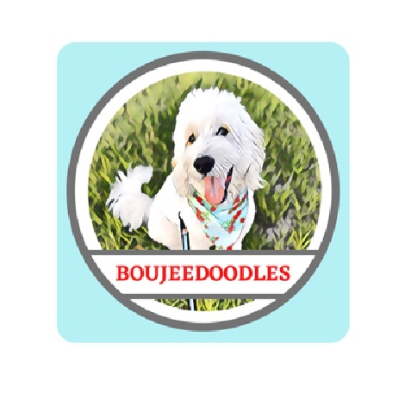

Thank you for deciding to add one of our puppies to your family. We want to make this a stress-free enjoyable experience for you. Please feel free to email, text, or call us with any questions you have along the way. We will keep you up to date with information about your puppy as it grows until it is time for your puppy to go to his/her new home. It is helpful to follow us on social media for daily pictures and video updates. This contract is written for the protection of both the breeder and the adopter. However, it is primarily written to protect the health and general wellbeing of the puppy

**Purchase Agreement**

1. Please read the health guarantee below before deciding to adopt a puppy. By placing a reservation on a puppy, you are agreeing to the terms and conditions within this contract.
2. We require a $500 reservation fee to reserve a puppy. This fee is nonrefundable as it takes away an opportunity for another family to have a place in whole puppy process, unless there is a problem with the health of your puppy as outlined below or there is a miscarriage of the litter. In that case, the adopter will receive a full refund. The remaining balance must be paid in full on or before pick-up, in the form of cash or Zelle. The full purchase price for our puppies is $2500, plus Texas sales tax. There is an extra charge of $1000 for any puppy with merle coloring. BoujeeDoodle past puppy families & military or first responders receive a 10% discount.
3. The buyer agrees to spay/neuter the puppy upon maturity as advised by your veterinarian. If altered before maturity, known as the closing of the growth plates, the health guarantee is void. This puppy is sold without breeding rights. If bred, the buyer agrees to pay Boujeedoodles the sum of $1000 cash or Zelle per puppy born.

**Health Guarantee**

1. The puppy will be ready to go to its new home usually at the age of 8 weeks, depending on the temperament, health, and how easily he/she is weaned from the mother. There is an additional $40 a day charge for puppies kept longer than the agreed upon puppy pick up date.

This additional fee is for boarding only. If you request additional training, please contact us.

1. The puppy is guaranteed to be in good health and will have been vet checked before the time of sale. The puppy will be up to date on vaccinations and worming at the time of pickup. It is very important that you continue the vaccinations and worming. Please do not expose your puppy to other dogs that are not vaccinated until he/she has completed the entire vaccination schedule - around 16-20 weeks old. We have provided one month of free health insurance which must be activated within 24 hours of puppy pick up for the health guarantee to be valid. You may cancel at any time after the month of free insurance. We do recommend health insurance for the life of your companion.
2. The adopter, at their own expense, must have the puppy examined by a licensed veterinarian within 72 hours of receiving the puppy to validate this health agreement. Documentation must be sent to the breeder within ten days for the Health Guarantee to be honored. If within 72 hours, a licensed veterinarian finds the puppy to be unhealthy or unfit for sale, the puppy may be returned for a full refund - provided the puppy has not been injured or neglected. The veterinarian must provide a written statement deeming the puppy “unhealthy for purchase”. Please send a copy of the visit through email to Boujeedoodles@gmail.com.
3. This guarantee does not cover any health and or behavior issues caused by neglect or injury from the family. Nor does this guarantee include minor illnesses and health issues such as colds, allergies, internal or external parasites or umbilical hernias.
4. The breeder gives a 2-year guarantee from the puppy’s date of birth, against any congenital defects that are life threatening. If this should occur, the puppy will be returned to the breeder along with written documentation from a licensed veterinarian, and the adopter will receive a full refund of the purchase price of the puppy.
5. If for any reason the adopter is unable to keep the puppy, the adopter agrees to return the puppy to **BOUJEEDOODLES** and not place the puppy in another home unless given permission by the breeder. If the puppy is returned in good health within the first 2 weeks, half of the purchase price will be refunded after the puppy has been placed in the new home. The other half will need to cover the cost of re-advertisement, current vaccinations, care and additional training until the puppy is placed in his/her new home.

Date of Birth: _____________________ Puppy Name _________________

Dam: ____________________________ Sire: _________________________

Breeder’s Signature: ____________________________________________

Purchaser’s Signature: ____________________________________________

Date: _____________________________